CHANGING THE MAINS VOLTAGE SELECTION IN ACOM1010
------------------------------------------------

This step-by-step instruction is about the way of changing the nominal mains voltage selection in ACOM1010 power amplifier. Please follow all details closely since the work might be dangerous for you and you might severely damage the amplifier with inadequate voltage selection. Do not hesitate to contact your local dealer or nearest ACOM's service for any advice.

1. Safe proofing and opening the amplifier.

WARNING HIGH VOLTAGE!
The amplifier works with voltages up to 3000 V dc, which are potentially LETHAL! You must unplug the amplifier from the line (mains) wall outlet and WAIT AT LEAST 30 minutes before removing the cover of the amplifier. Do not touch any part inside before you safe proof the amplifier as described below because some residual voltages may still be present. If you don’t feel comfortable with amplifier repairs or you are not sure about your safety, we recommend that you entrust the following operations to your dealer.

a) Unplug the amplifier from the line (mains) wall outlet. Disconnect the mains cord from amplifier rear panel. Disconnect all cables from the amplifier (grounding last).

b) Wait at least 30 minutes before to continue.

2. Removing the top cover.

Using a Philips-2 screwdriver, unscrew 11 pcs of flange-button head screws - three on the rear edge and 2x4 pcs on both sides - fig.1:

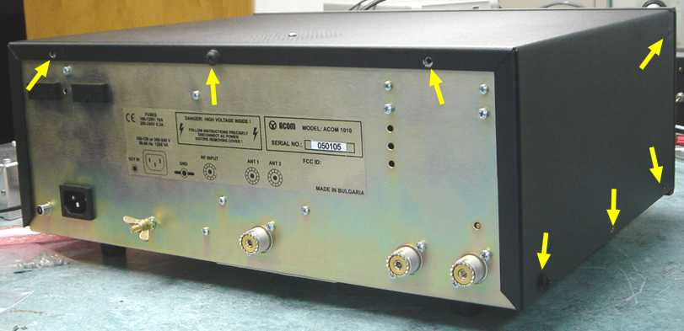

Fig.1 Cover Screws

a) Lift the rear cover edge and rotate the cover to about 30-45 degrees to release it from the front panel chute. Then pull the cover backwards and upwards while shaking it slightly in order to remove it - fig.2:

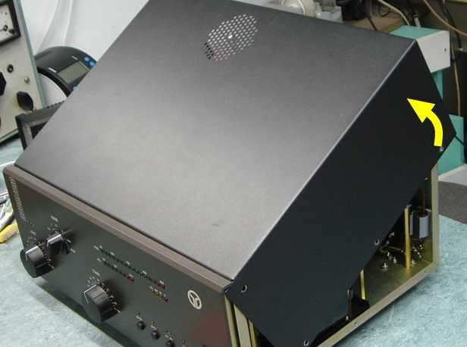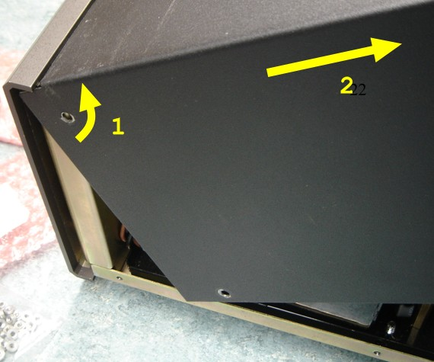

Fig.2 Top Cover Removal

b) Check whether the High Voltage Crowbar (located on the middle chassis wall) does reliably short-circuit its center screw to the chassis when the top cover is removed. It must keep the HV circuit connected to the chassis ground during all your operations - fig.3:

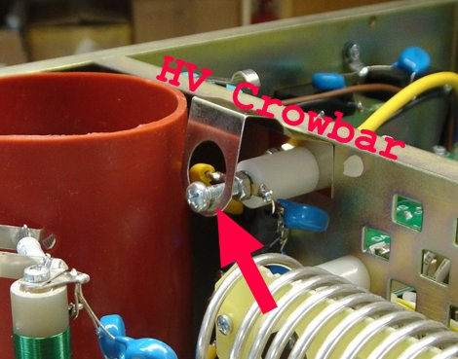

Fig.3 High Voltage Crowbar

3. Changing the mains-voltage selection jumpers

The MAINS PCB is located in the right-hand compartment of the amplifier, just above the HV transformer - see Fig.4.

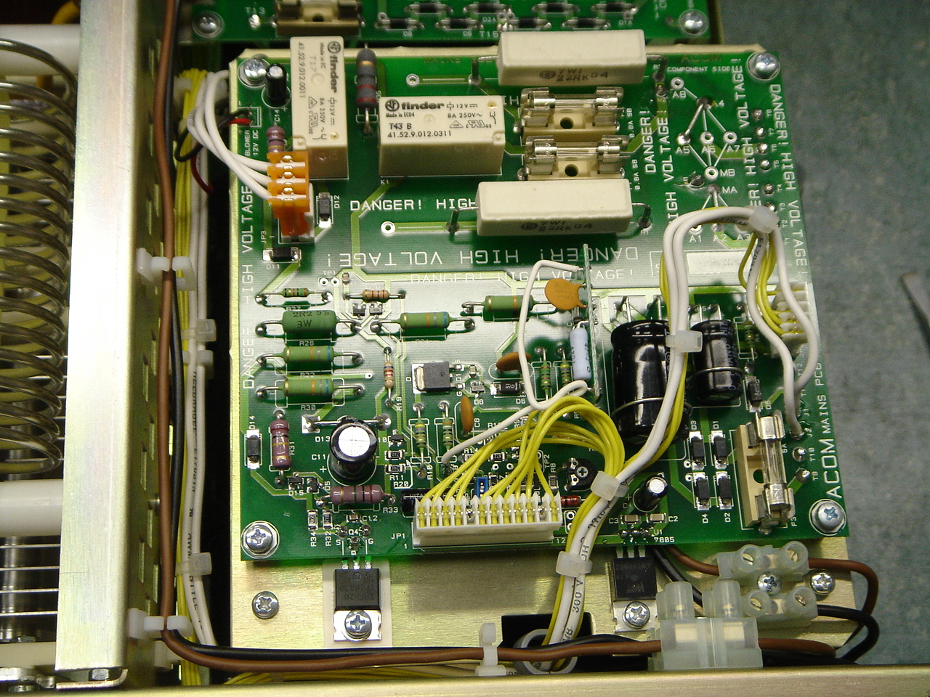

Fig.4 Mains PCB and voltage-selection jumpers location
The voltage selection jumpers are located at the right-hand rear corner of the PCB. Look at fig.5 and find the picture corresponding to your voltage. Compare it with the existing jumpers and reconnect them as required. Make sure you have made good solderings as the whole mains current will flow through these jumpers.

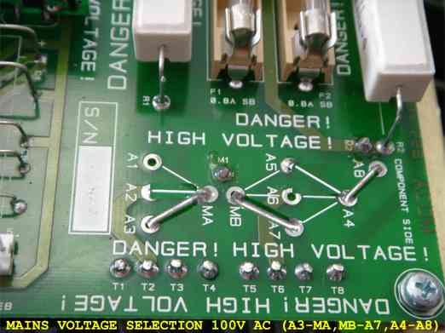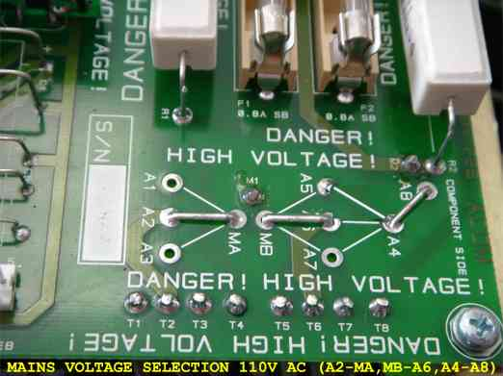
100V AC 110V AC

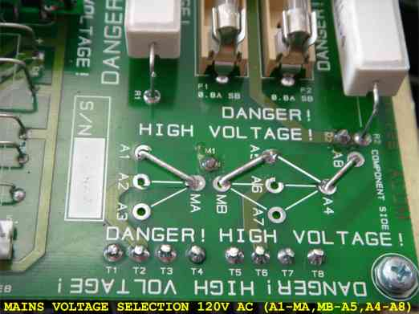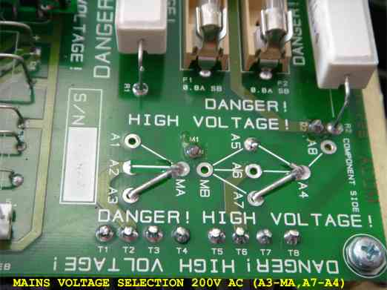
120V AC 200V AC

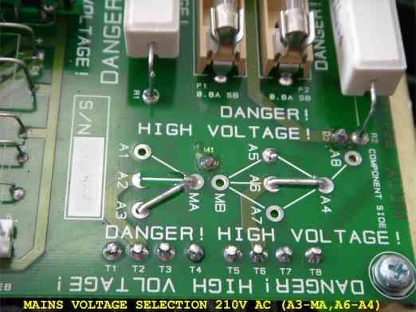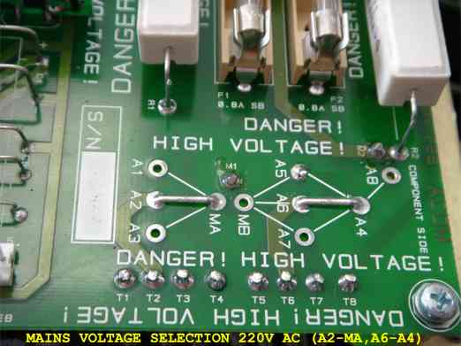
210V AC 220V AC

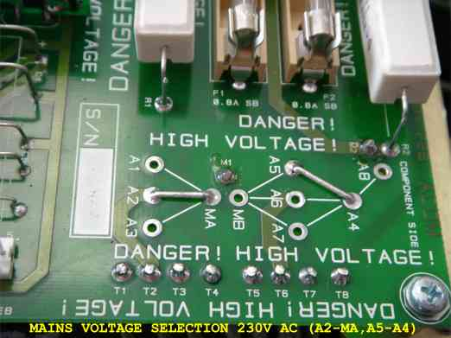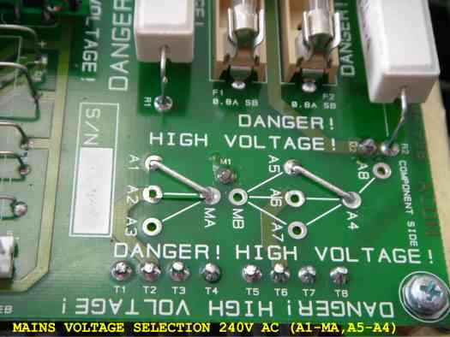
230V AC 240V AC

Fig. 5 Voltage selection jumpers for
100, 110, 120, 200, 210, 220, 230, and 240VAC

4. Checking the mains fuses.

Extract the mains fuses (located on the rear panel) and check their rated current. For 100-120VAC you would need 10A fuses. For 200-240VAC the fuses must be 6.3A. Replace the fuses as required.

WARNING
If your amplifier is only fitted with one line (mains) fuse, it is suitable for the European Community ONLY. You should check with a qualified electrician if the amplifier is to be used outside the country in which it was purchased.

5. Top Cover installation.

a) Put the cover on the chassis while holding its rear edge lifted to 15-20cm (the cover inclined to 30-45 degrees - look at fig.2). Align the horizontal cover edge to the respective front-panel chute.

Push the cover forwards and downwards while shaking it gently, in order to insert the cover edge into the front-panel's chute. Use similar motion like when you were removing the cover but in reverse sequence.

Take care that the bottom corners of the cover do not steal inside the chassis while you are closing the cover by pushing it downwards.

b) Use a Philips-2 screwdriver. Screw in loosely all 11 pcs of flange-button head screws - look at fig.1 again.

c) While pressing the cover continuously forwards and downwards, tighten all 11 screws properly.

- End -

